## Problem 4 – SoftUni Landing Page

Create a web page (**HTML** + **CSS**) that looks and behaves like the screenshots below:

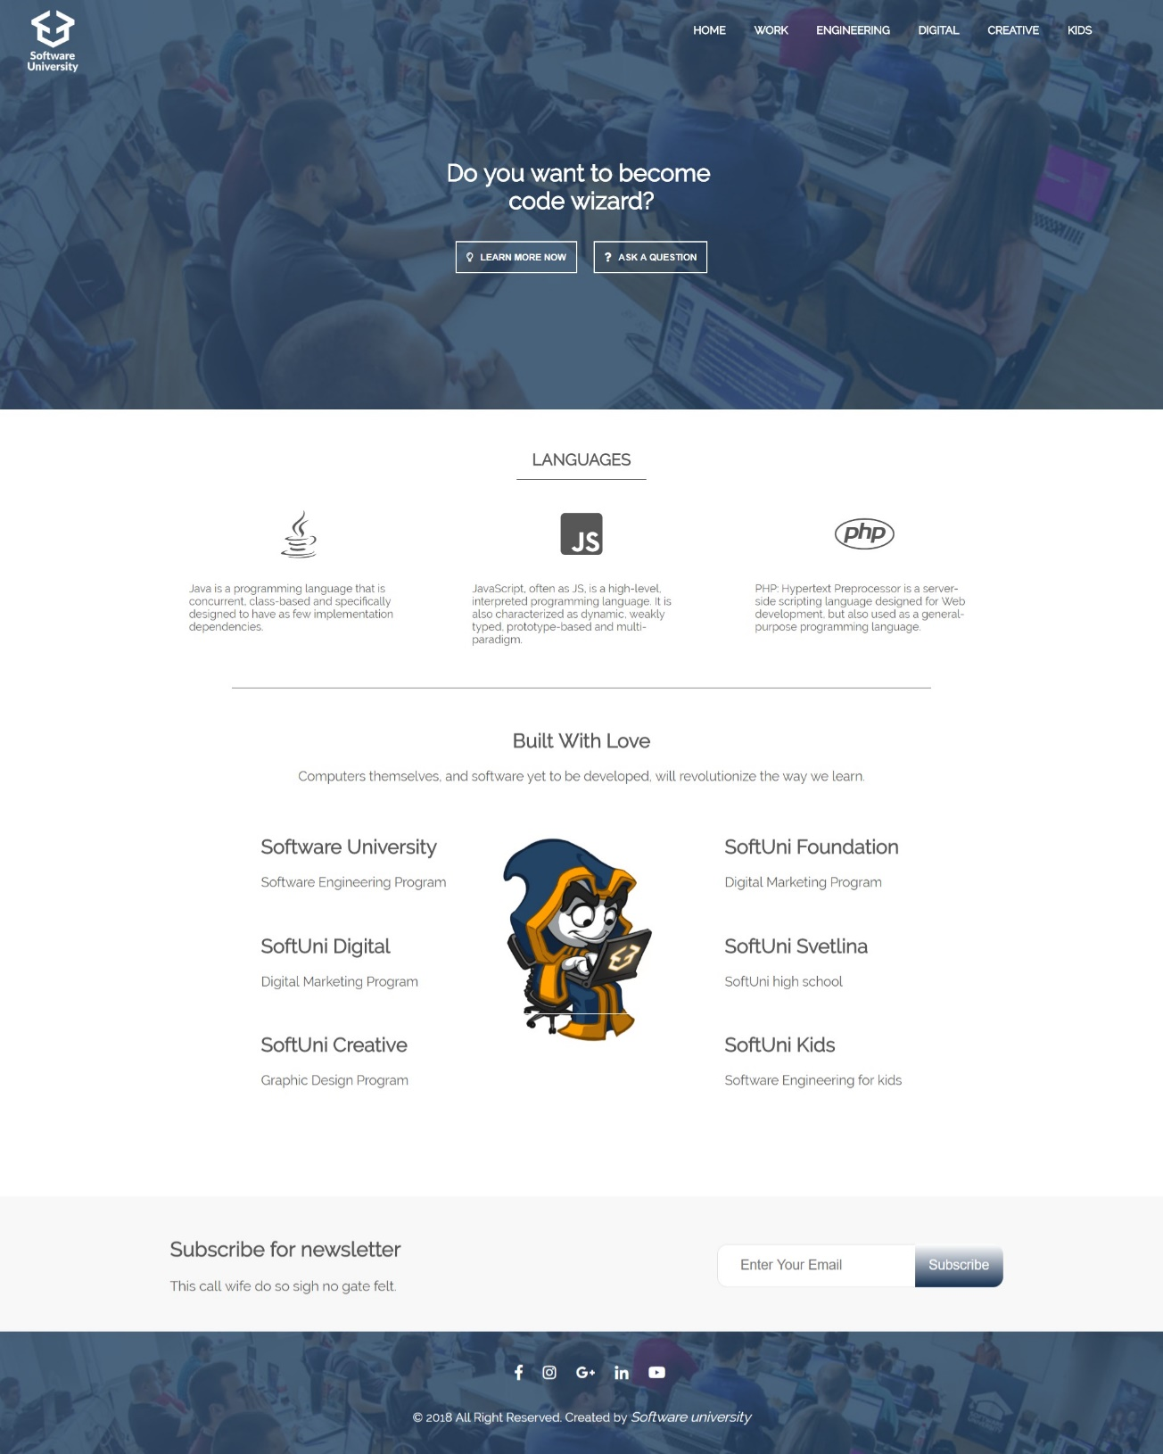

### Input

You are given the above screenshots + all required images + the texts on the site.

### Output

The output should be valid HTML + CSS + images that implement the above web page.

### Constraints

* Use google font **Raleway** - https://fonts.google.com/specimen/ **Raleway**
* Use Font Awesome - <https://use.fontawesome.com/releases/v5.0.13/css/all.css>
* The site should open correctly in the latest version of Chrome
* Pixel-perfect implementation is not required

### Hints

* You can use this gradient for the special button in subscribe section:

background: linear-gradient(#fff, #132e4f);

* Don’t forget to implement hover effects